PROJECT REPORT
Women’s Clothing: Trends and Analysis
in the Fashion Industry
Dynamic Customer Age Segmentation Using K-Means and Decision Trees
Task
Create a new feature that categorizes customers into dynamically determined age groups using clustering techniques instead of predefined ranges.
Dataset: Women’s Clothing E-Commerce Reviews | Records: 23,486

Executive Summary
This project developed a data-driven customer age-segmentation feature for the Women’s Clothing dataset. Instead of manually assigning fixed age bands, multiple K-Means solutions were evaluated with the Elbow Method, Silhouette Score, segment balance, and interpretability. A Decision Tree was also evaluated to identify age thresholds associated with changes in recommendation behaviour. The final solution selected four K-Means segments: 18–33, 34–44, 45–57, and 58–99. The resulting feature, Dynamic_Age_Group, assigns every customer to a relevant and interpretable segment without missing values.

1. Introduction
Age is an important customer characteristic in fashion analytics because preferences, satisfaction, engagement, and recommendation behaviour can vary across customer life stages. Traditional analysis often uses manually predefined categories such as 18–25 or 26–40. Such ranges may not reflect the actual distribution of customers in a specific dataset. This project therefore uses machine-learning techniques to discover age boundaries from the data itself.

2. Problem Statement
The dataset contains customer ages but does not contain a meaningful age-group feature. Predefined age ranges may create unbalanced or irrelevant segments. The problem is to dynamically determine suitable age bins using clustering and tree-based techniques, compare the alternatives, and create a final feature that supports meaningful customer analysis.

3. Project Objectives
Objective 1: Validate and analyse the Age column before modelling.
Objective 2: Identify natural age clusters by testing multiple K-Means configurations.
Objective 3: Use Decision Tree analysis to discover behaviour-based age thresholds.
Objective 4: Compare methods using statistical quality, stability, balance, and business interpretability.
Objective 5: Create and validate a final Dynamic_Age_Group feature for all records.

4. Dataset Overview
Property | Observed value
Dataset dimensions | 23,486 rows × 11 original columns
Age data type | Integer
Age range | 18–99 years
Mean / median age | 43.20 / 41 years
Age standard deviation | 12.28 years
Missing Age values | 0
Duplicate rows | 0
Behaviour fields used | Rating, Recommended IND, Positive Feedback Count

Missing values were present in Title, Review Text, Division Name, Department Name, and Class Name, but they did not prevent age segmentation because Age and the selected behavioural variables were complete.

5. Methodology
Step | Activity | Purpose
1 | Data validation | Checked data types, missing values, valid range, duplicates, and age statistics.
2 | Distribution analysis | Used histogram, KDE, boxplot, quartiles, and IQR-based outlier review.
3 | Feature preparation | Converted Age to a two-dimensional feature and applied StandardScaler for K-Means.
4 | K-Means evaluation | Tested K = 2 to 10 using inertia and sampled Silhouette Scores.
5 | Candidate review | Compared boundaries, customer counts, balance, and interpretability for K = 2, 3, 4, 5, and 7.
6 | Decision Tree evaluation | Predicted Recommended IND from Age using stratified five-fold ROC-AUC validation.
7 | Complexity control | Applied the One-Standard-Error Rule and a 5% minimum leaf-size requirement.
8 | Final selection | Selected the method offering relevant, balanced, stable, and interpretable segments.

6. K-Means Analysis
K-Means was fitted on standardized Age values. Because clustering is unsupervised, a train–test split was not required for the segmentation stage. Different values of K were evaluated to avoid selecting the number of groups arbitrarily.
K | Inertia | Silhouette Score
2 | 7,446.74 | 0.5941
3 | 3,905.49 | 0.5420
4 | 2,325.33 | 0.5415
5 | 1,567.60 | 0.5469
6 | 1,171.98 | 0.5422
7 | 855.25 | 0.5536
8 | 685.35 | 0.5418
9 | 541.03 | 0.5355
10 | 445.29 | 0.5403

K = 2 produced the highest Silhouette Score but created only two broad groups. K = 7 produced a relatively strong score but left only 1.62% of customers in the oldest segment. K = 4 was selected as the best practical K-Means solution because it lies near the elbow region and produces four balanced, interpretable groups; its smallest segment still contains 14.37% of customers.

7. Final K-Means Segments
Segment | Age range | Customers | Share | Avg rating | Recommend | Avg feedback
Segment 1 | 18–33 | 5,263 | 22.41% | 4.18 | 80.83% | 2.02
Segment 2 | 34–44 | 8,575 | 36.51% | 4.18 | 81.76% | 2.63
Segment 3 | 45–57 | 6,272 | 26.71% | 4.19 | 82.35% | 2.63
Segment 4 | 58–99 | 3,376 | 14.37% | 4.30 | 85.43% | 2.92

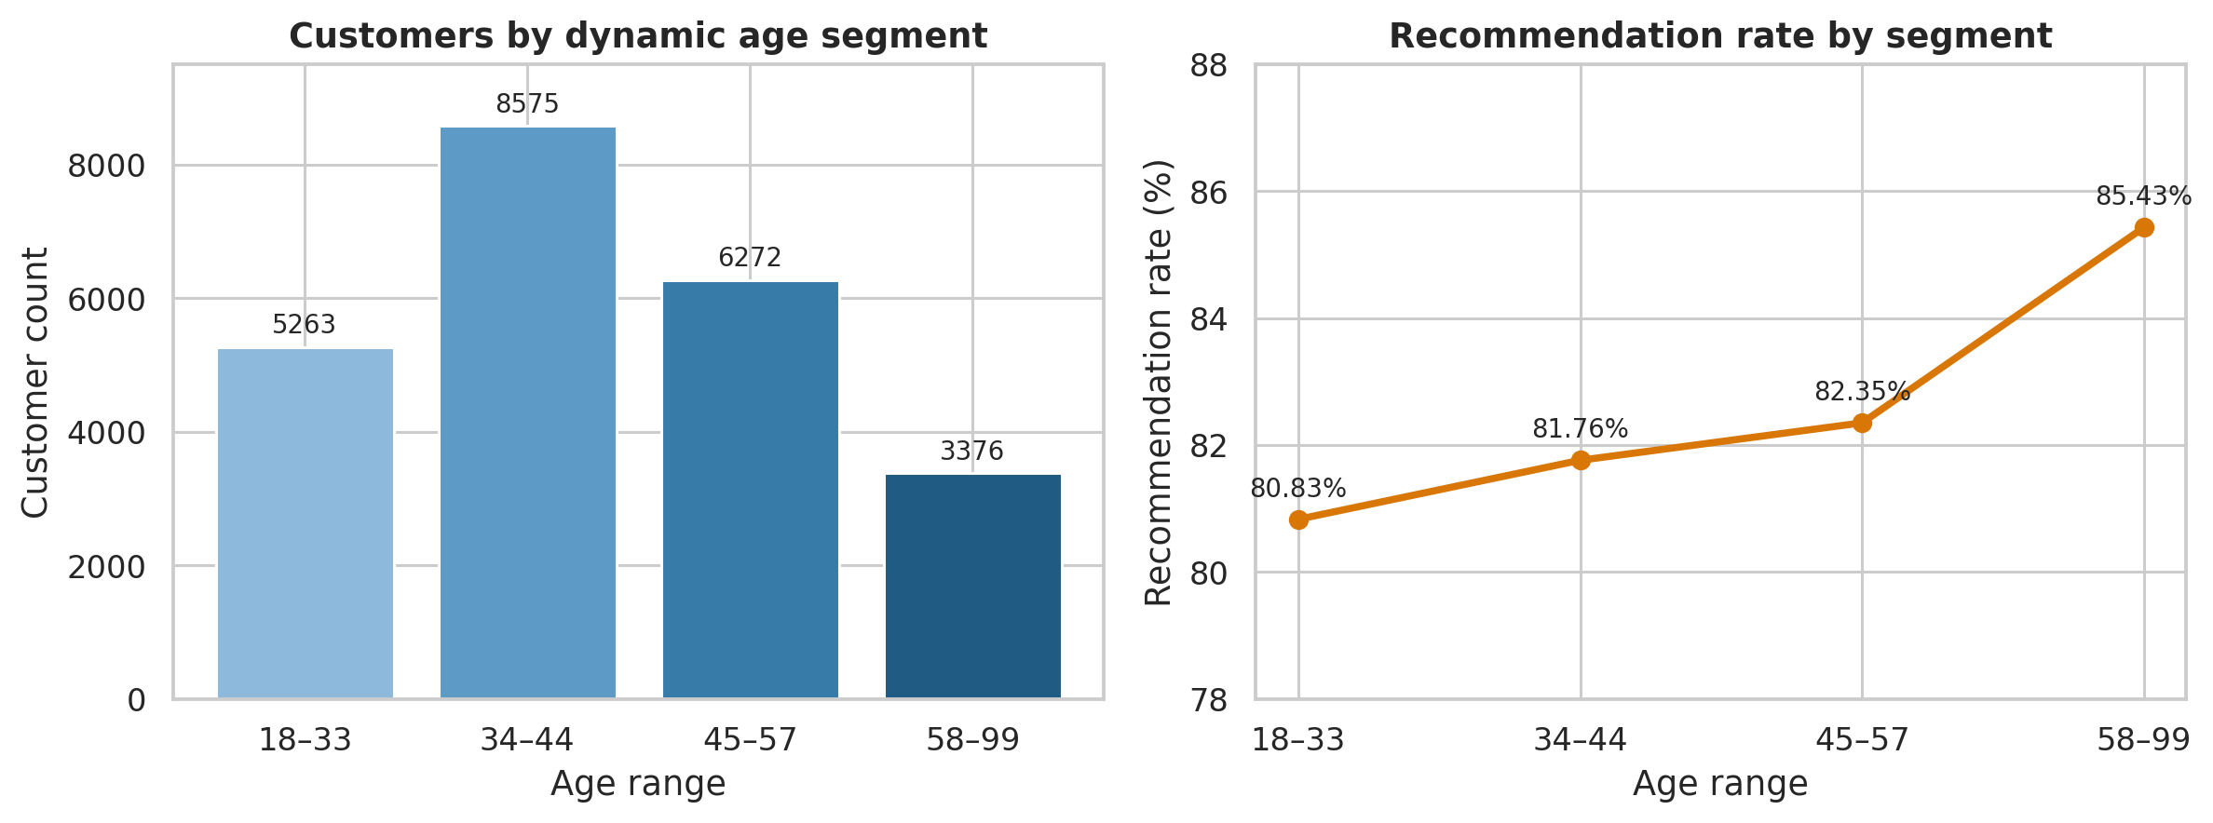
Figure 1. Customer distribution and recommendation rate across dynamically generated age segments.

8. Decision Tree Analysis
A DecisionTreeClassifier used Age as the input and Recommended IND as the behavioural target. Candidate trees with two to eight leaf segments were evaluated using stratified five-fold ROC-AUC. The One-Standard-Error Rule selected a simpler five-leaf solution with performance statistically close to the highest-scoring candidate.
Tree segment | Age range | Customers | Recommendation rate
1 | 18–25 | 1,223 | 85.12%
2 | 26–38 | 8,141 | 80.00%
3 | 39 only | 1,269 | 87.31%
4 | 40–53 | 7,920 | 81.55%
5 | 54–99 | 4,933 | 85.00%

The selected tree’s ROC-AUC was approximately 0.53, only slightly above the random-discrimination baseline of 0.50. Age alone therefore had weak predictive power for recommendations. The tree also isolated Age 39 as a dedicated segment, which captures a local behaviour difference but is too specific for a general-purpose business segmentation feature.

9. Method Comparison and Final Selection
Criterion | K-Means | Decision Tree
Basis | Natural age distribution | Recommendation behaviour
Selected groups | 4 | 5
Primary metric | Silhouette Score = 0.5415 | CV ROC-AUC ≈ 0.53
Smallest segment | 14.37% | Approximately 5.4%
Key strength | Balanced and interpretable | Behaviour-aware thresholds
Key weakness | Does not directly optimize a target | Weak prediction; one single-age group
Decision | Selected | Used as supporting comparison

Final decision: K-Means was selected because it produced natural, reasonably balanced, stable, and easy-to-interpret customer segments. The Decision Tree result was retained as evidence that behaviour-based cut-points were tested, but it was not used for the final feature due to weak predictive separation and an over-specific single-age segment.

10. New Feature Created
Feature name: Dynamic_Age_Group
Feature type: Ordered categorical variable
Coverage: 23,486 of 23,486 records; 0 missing assignments
Values: Segment 1: 18–33; Segment 2: 34–44; Segment 3: 45–57; Segment 4: 58–99
The labels include both a segment number and its data-derived age range. Cluster identifiers were reordered by ascending cluster centre so that Segment 1 consistently represents the youngest group and Segment 4 the oldest.

11. Key Business Insights
Customer concentration: The 34–44 segment is the largest, representing 36.51% of all customers.
Recommendation trend: Recommendation rates generally rise across the ordered age groups, from 80.83% in ages 18–33 to 85.43% in ages 58–99.
Customer satisfaction: The 58–99 segment has the highest average rating at approximately 4.30 out of 5.
Engagement: Average positive-feedback count is highest in the oldest segment at approximately 2.92.
Marketing relevance: The dynamic feature can support age-aware campaign analysis, product-category comparisons, and recommendation studies.

12. Limitations
Age was the only variable used to form the K-Means clusters, so the final segments represent age-distribution structure rather than complete customer personas. The dataset contains product reviews rather than unique customer identifiers, which means repeated individuals cannot be reliably identified. Very old ages are statistically rare but were retained because they are plausible and may represent a meaningful senior segment. Decision Tree performance also showed that Age alone is insufficient for strong recommendation prediction.

13. Future Scope
Future work could create multivariate customer segments using Age together with Rating, recommendation behaviour, feedback count, department, and product class. Cluster stability could be tested across resampled datasets or time periods. If unique customer and transaction identifiers become available, the analysis could include purchase frequency, monetary value, retention, and lifetime-value measures.

14. Tools and Libraries
Tool / library | Use in the project
Python | Implementation language
Pandas / NumPy | Data preparation and statistical summaries
Matplotlib / Seaborn | Distribution and segment visualizations
Scikit-learn | StandardScaler, KMeans, DecisionTreeClassifier, cross-validation, and evaluation

15. Conclusion
The project successfully replaced arbitrary age bands with data-driven customer segments. Multiple K-Means configurations and a behaviour-based Decision Tree were systematically evaluated. Four K-Means groups were selected as the final solution because they offer the best balance of statistical separation, segment size, interpretability, and practical relevance. The new Dynamic_Age_Group feature contains no missing assignments and reveals clear differences in customer recommendation, rating, and feedback behaviour. The completed output is suitable for further exploratory analysis, reporting, and customer-segment comparisons in the Women’s Clothing project.

